DO COMMUNITIES THAT EXPERIENCED REDLINING HAVE HIGH ENERGY BURDENS

DANAE HERNANDEZ-CORTES

SPRING 2024

BY: MARYCLAIRE OKORO

# TABLE OF CONTENTS

TABLE OF CONTENTS 2

ABSTRACT 3

INTRODUCTION 4

LITERATURE REVIEW 5

REDLINING AND HEALTH-RELATED OUTCOMES 6

REDLINING AND ENVIRONMENTAL INJUSTICE 7

REDLINING AND ENERGY INSECURITIES 8

GAPS IN PREVIOUS RESEARCH 9

METHODOLOGY 10

DATA SOURCE 10

VARIABLES 10

DATA ANALYSIS 10

RESULTS 12

DISCUSSION 16

CONTEXT AND FOCUS OF THE STUDY 16

RACIAL AND ECONOMIC DISPARITIES IN ENERGY BURDEN 16

HOMEOWNERSHIP AND HOUSING STABILITY 17

INCOME DISPARITIES 17

ENERGY INSECURITY AND RACIAL DISPARITIES 17

HOUSING TYPE AND CONSTRUCTION YEAR 18

RACIAL DISPARITIES IN ENERGY SOURCE RELIANCE AND ITS ECONOMIC IMPLICATIONS 18

LIMITATIONS OF THE STUDY 18

RECOMMENDATIONS FOR FURTHER RESEARCH 19

CONCLUSION 20

REFERENCES 21

Table of Figures

Figure 1:HOLC Residential Security Map 6

Figure 2: Conceptual model of the pathway of historical health outcome 7

Figure 3: Distribution of Ownership Status by Race 13

Figure 4: Income Distribution by Race 14

Figure 5: Frequency of Reducing Necessities Due to Energy Bills by Race 14

Figure 6: House Type Distribution by Race 15

Figure 7: Construction Year Distribution by Race 15

Figure 8: Electricity-Only Usage by Race 16

Figure 9: Energy Costs Across Income Ranges 16

# ABSTRACT

In a time when social justice is becoming more and more centered around energy equity, this study explores the long-lasting effects of redlining in the past on current energy burdens. With a focus on Michigan, the study examines how historical injustices continue to influence the patterns of energy use and housing stability among various ethnic and socioeconomic groups. It does this by analyzing data from the 2020 Residential Energy use Survey (RECS), which was updated in January 2024.  
  
Significant differences in energy costs and property ownership are shown by the quantitative analysis. While the majority of minority households are either renters or have non-paying occupants, white households own their homes to a greater extent. Minority groups bear a disproportionate amount of the energy load in relation to their income, which highlights the financial constraints on these communities. This discrepancy also applies to energy burdens.

Additionally, the research contextualizes these disparities within the historical framework of the Home Owners' Loan Corporation (HOLC), illustrating how redlining has left a lasting imprint on housing and energy inequalities. The implications of these findings suggest a sustained influence of redlining on housing stability and energy security, prompting a need for targeted policy interventions.

Despite providing insightful observations, the study acknowledges limitations due to significant missing data and a dataset predominantly composed of White respondents, which could affect the generalizability of the findings. Future research should employ a more comprehensive dataset and expand beyond Michigan to better understand the national implications.

This project sheds light on the intersection of race, housing, and energy and urges a reevaluation of policies to mend the longstanding rifts caused by historical injustices, ensuring energy equity for all.

# INTRODUCTION

In the aftermath of the Great Depression, the federal government-established Home Owners' Loan Corporation (HOLC) began a procedure known as redlining, which assessed area investment risks based on characteristics such as resident ethnicity, income, and housing problems. This approach defined the geography of wealth and poverty, laying the groundwork for long-standing inequities that continue to shape metropolitan environments today. This article investigates the relationship between these historical segregation indicators and modern energy insecurity, specifically if communities affected by redlining face a greater energy burden.

The HOLC, formed by the Federal Home Loan Bank Board (FHLBB) in the 1930s, sought to maintain property values and coordinate federal efforts with private lenders. It assessed real estate risk in 239 cities, providing maps that classified areas from A, the lowest danger, to D, the highest risk (Hillier, 2003). Entire neighborhoods, rather than individual properties, were evaluated, with lower grades primarily assigned to African American and Hispanic communities, leading to accusations of systemic racism because these areas were frequently denied mortgage loans (Jackson, 1980; Cooney & Jackson, 1987; An et al., 2019).

According to Swope et al. (2022), neighborhoods classified as hazardous, or 'D' grade, were characterized by substandard dwelling conditions and antiquated infrastructure. As a result, inhabitants faced higher property expenses and greater energy expenses. Redlining maps institutionalized geographic discrimination, but prior to the creation of the maps, there may have been preexisting bias among lenders as evidenced by their reluctance to grant credit to particular regions (Chicago: University of Chicago Press, 1922).  
  
This study emphasizes how crucial it is to look at energy loads within redlined neighborhoods because of their long-standing economic strains and inefficient infrastructure. These elements make health and wellbeing problems worse since struggling households would not be able to afford the essential heating or cooling, which could put them at risk for illness during severe weather.

In order to reduce energy expenditures, right historical wrongs, and enhance living circumstances in marginalized communities, focused policy actions can be informed by an understanding of the overlap between past prejudice and present energy inefficiencies.  
  
This study intends to shed light on the socio-economic effects of discriminatory policies and provide insights that could lead to more equitable energy policy and improved community planning by investigating the relationship between redlining and energy burden. This is crucial for directing initiatives that support sustainability and lower energy bills in groups that have historically been excluded.

# LITERATURE REVIEW

Throughout the 20th century, racial segregation and inequality profoundly influenced American cities and influenced the social and political landscape of the country. Redlining, a practice where home mortgages and other financial services were often rejected based on the alleged danger associated with a region, was one of the most well-known instruments for encouraging segregation. The Federal Housing Administration (FHA) later adopted this technique once it was institutionalized by the Home Owners' Loan Corporation (HOLC). Redlining is the process by which the federal government assesses an area's suitability for investment by considering many aspects such as demography, community stability, infrastructure quality, and proximity to either desirable or unwanted qualities (Winling & Michney, 2021). The evaluations conducted by HOLC in the 1930s explicitly discriminated based on race and ethnicity, thereby reinforcing and formalizing existing patterns of segregation and discrimination with federal endorsement.

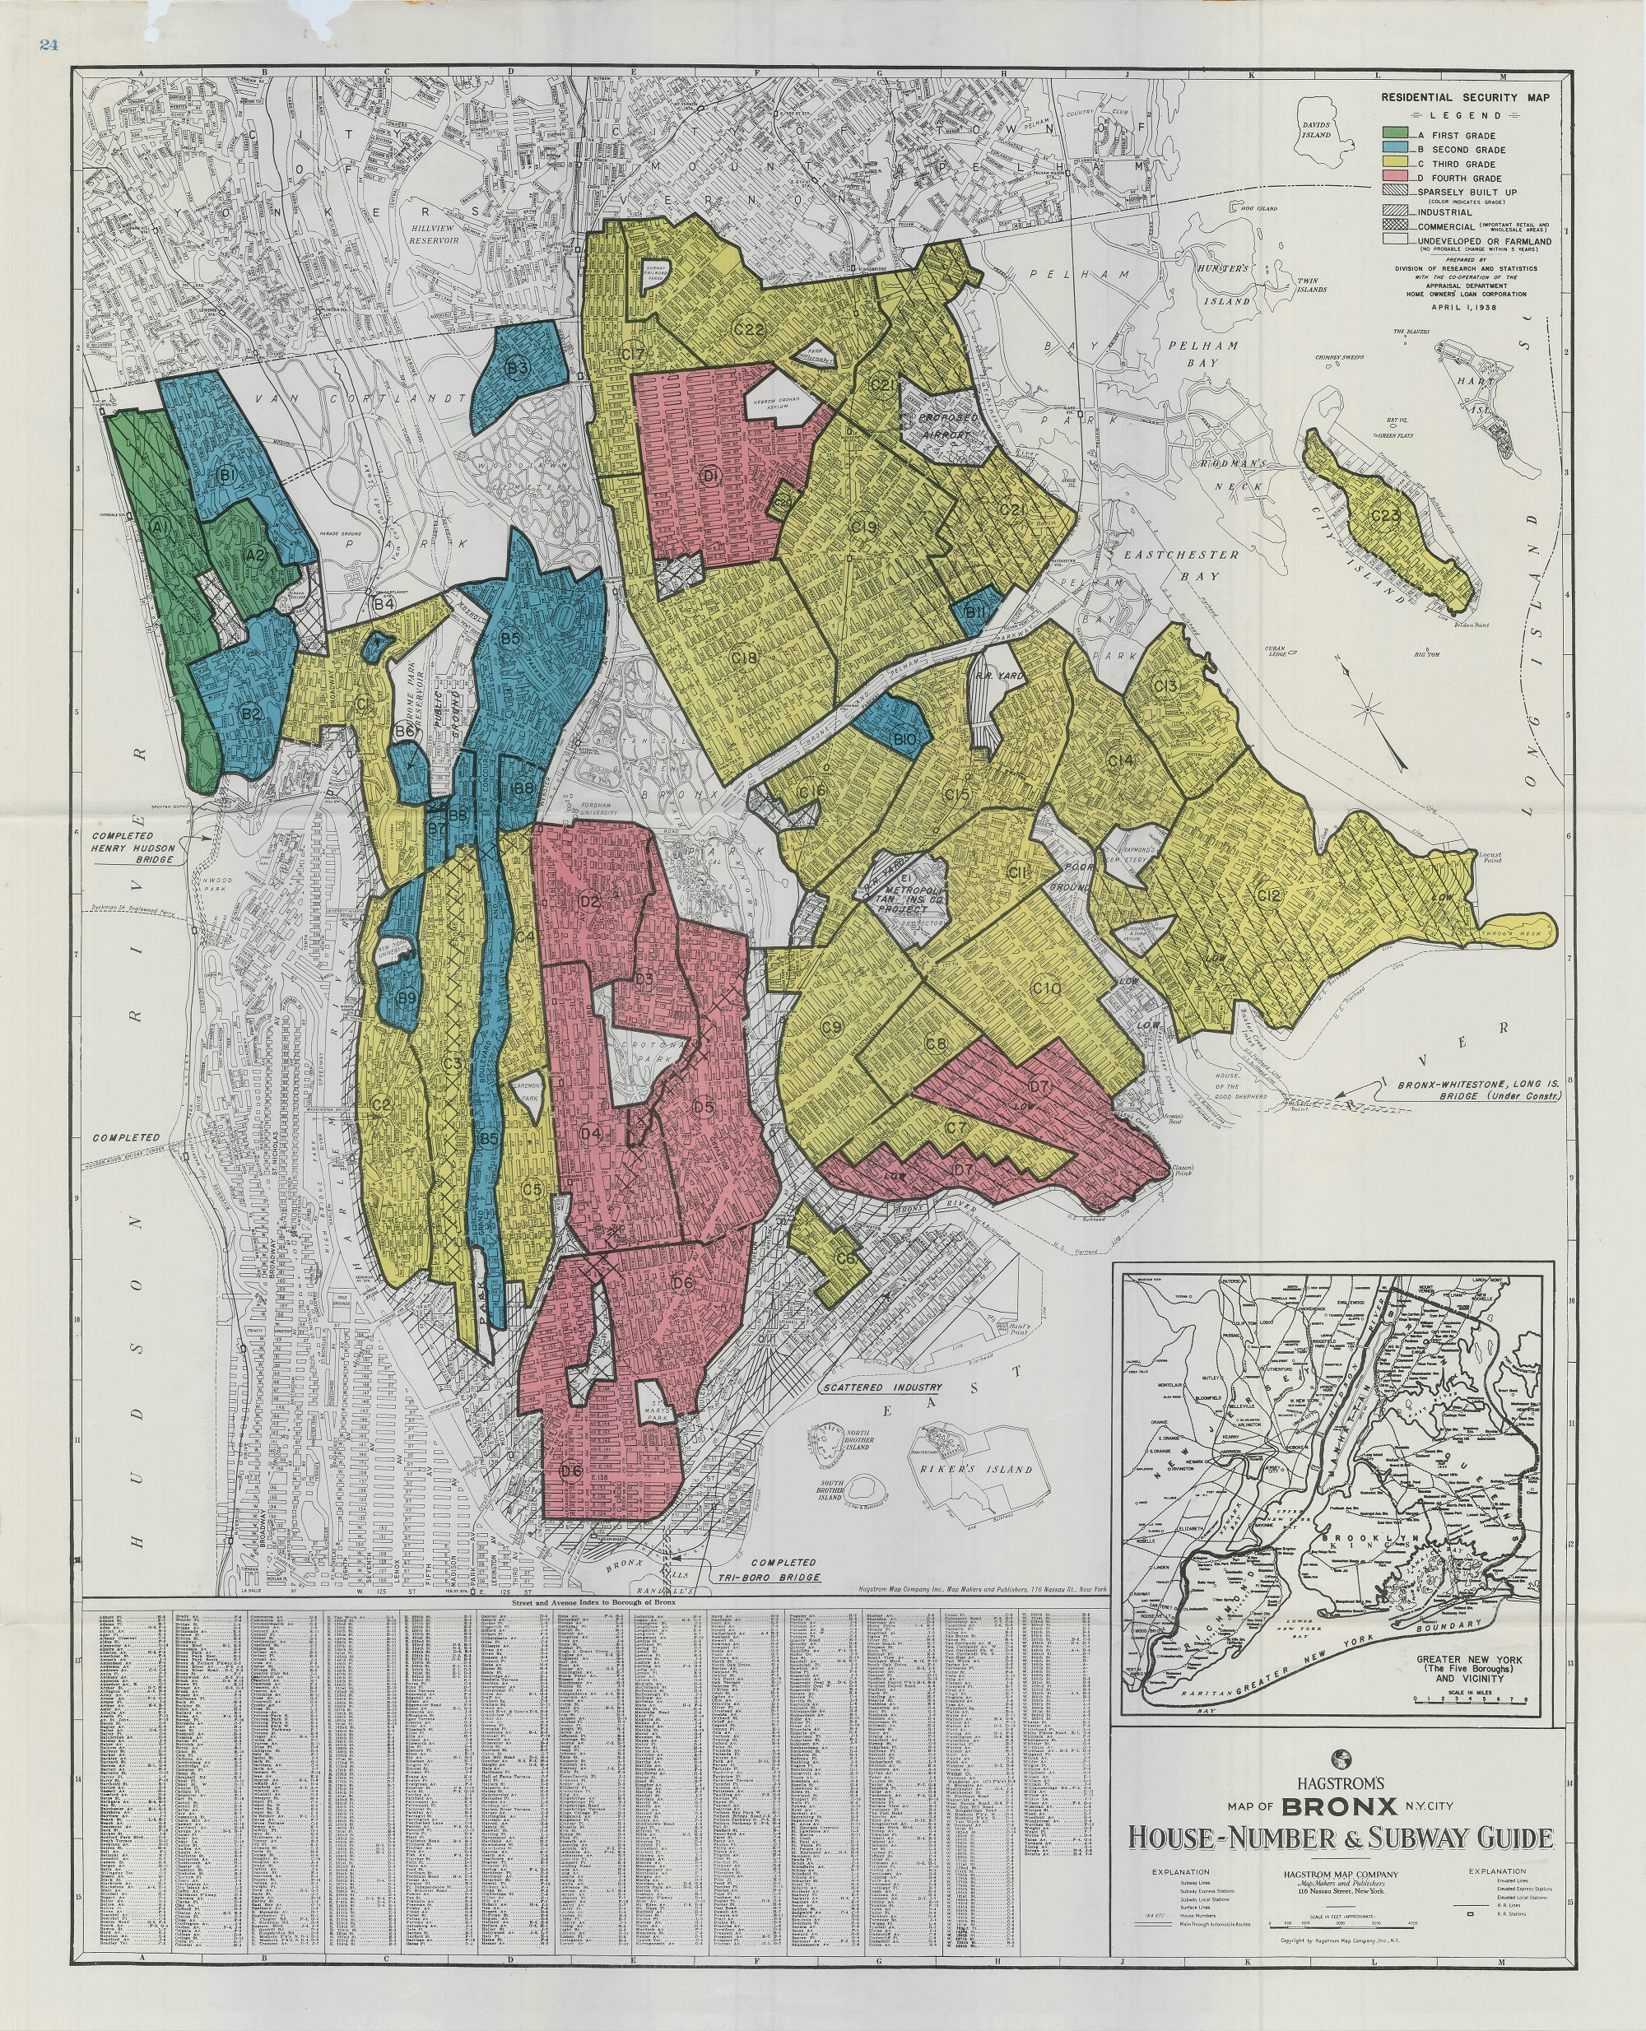

Figure 1:HOLC Residential Security Map

This figure presents the residential security map commissioned by the HOLC for Bronx County, New York. Areas are classified into four grades, as described in the text. The entire sample consists of 58 such maps covering 48 MSAs (Appel, 2016).

Redlining has officially ended, but its impacts are still felt in the twenty-first century, influencing laws, healthcare, economics, and urban planning, among other socioeconomic facets. Discrimination has left a lasting legacy that has fueled systemic inequality, which disproportionately affects communities of color. There are severe differences in these groups' access to healthcare and economic prospects. They are often located in places where there is not enough tree canopy, which exacerbates the negative impacts of urban heat and environmental injustices. In addition, the conspicuous lack of all-encompassing policies aimed at mitigating the lingering effects of redlining implies that these historically disadvantaged communities have heightened degrees of energy insecurity and relatively raised energy expenses.

Historically, redlining led to significant disinvestment in minority communities, predominantly those with low incomes, cementing a cycle of poverty and disadvantage that persists today (Massey and Denton 1995). The policy favored white individuals by offering more favorable lending rates, enabling them to accumulate more incredible wealth and equity than their African and Hispanic American counterparts (Traub et al. 2016).

This ongoing issue highlights the critical need for targeted interventions to alleviate the enduring effects of past discriminatory practices on current generations.

## REDLINING AND HEALTH-RELATED OUTCOMES

Drawing on data from the Cook County Medical Office in Illinois, Bertocchi & Dimico (2020) analyze the profound impact of socio-economic factors on the health outcomes of African Americans. Their findings highlight that many African Americans live in impoverished areas characterized by high unemployment and inadequate housing. These conditions not only contribute to low socio-economic status but also to elevated rates of comorbidities. As a result, these socio-economic challenges have impeded the ability of many individuals to follow COVID-19 preventative measures such as social distancing, primarily due to reliance on public transportation and the inability to work from home.

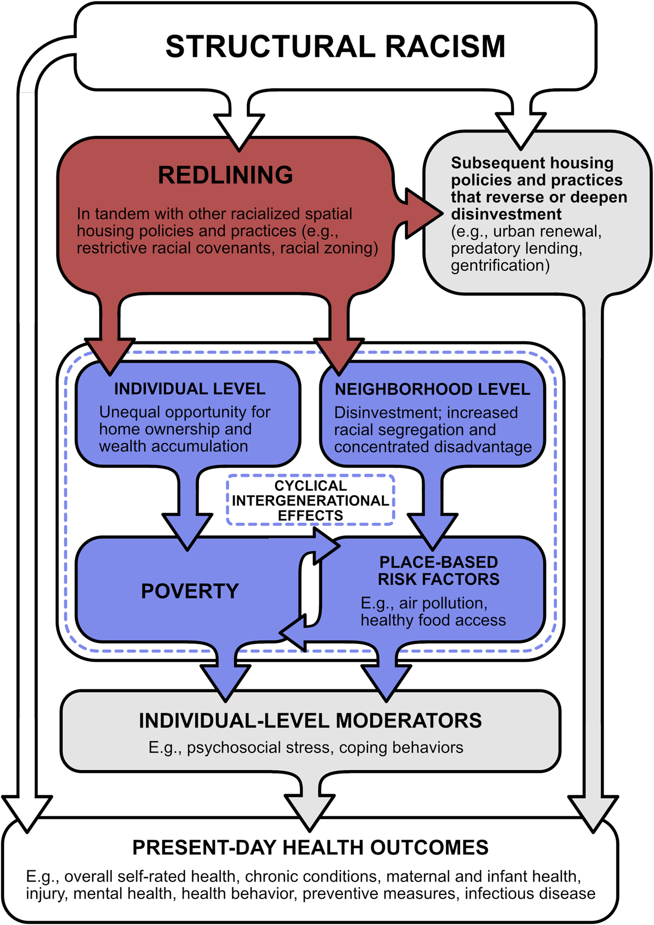

Figure 2: Conceptual model of the pathway of historical health outcome (Swope et al., 2022c)

In parallel, Yancy (2020) corroborates these findings and further discusses the historical context of redlining, which confirmed that these discriminatory practices were linked to the higher mortality rates experienced during the COVID-19 pandemic among African American communities. Yancy advocates for a holistic approach to these health crises, emphasizing the need for policies that simultaneously address the direct health impacts and the underlying socio-economic determinants. His analysis calls for tackling deep-rooted inequalities to enhance African Americans' long-term health and social outcomes, echoing the conclusions drawn by Bertocchi & Dimico. **Research has also shown that within this segregation, the lowest class (referred to as' class D') experienced significantly higher temperatures compared to classes A to C** (Wilson, 2020)**, which in turn makes them fortunate to health-related issues.**

The findings from CDC's 500 Cities project data are pivotal for my research into the enduring impacts of historical inequalities on health disparities (Data_cdc_places, 2018). By correlating 2010 Census data with historical HOLC Security Maps, the study confirmed that lower HOLC risk grades correlate with lower incomes and higher proportions of people of color. Notably, neighborhoods with the lowest grades (grade D) exhibited significantly worse health outcomes, such as increased asthma and poor mental health rates (Nardone et al., 2020) (Tsai et al., 2023). These insights bolster my research thesis that historical redlining continues to shape contemporary health disparities, emphasizing the need for health interventions that address these deep-seated inequalities.

## REDLINING AND ENVIRONMENTAL INJUSTICE

The segregation policies enforced by the Federal Housing Administration (FHA) became a significant burden for African Americans, who were systematically denied homes in predominantly white suburbs (Air, 2015) under the mistaken belief that their presence would decrease property values. Contrarily, property values increased when African Americans, constrained by severe housing restrictions, attempted to buy homes in these areas due to their limited choices and willingness to pay more (Rothstein, 2017). This exclusion from the suburban housing markets significantly hindered African Americans' ability to build wealth through home equity, exacerbating the vast wealth disparities between African Americans and whites.

Rothstein argues that the longstanding housing policies have deeply influenced American society. He explains that the persistent segregation in metropolitan areas contributes to enduring inequality. This environment hampers upward mobility for families residing in segregated neighborhoods, where opportunities are scarce. Rothstein emphasizes that to achieve greater equality and reduce tensions, such as those between police and young African-American men, proactive steps must be taken toward desegregation (NPR, 2017).

Moreover, FHA policies did more than segregate residential spaces; they also entrenched environmental injustices. African American communities were frequently relegated to areas with poorer living conditions, limited infrastructure, and more excellent proximity to environmental hazards (Gross, 2017).  
  
The legacy of systemic racism embedded in redlining continues to impact neighborhoods, which now experience higher levels of energy burden, energy insecurity, and pollution exposure. Communities that were once redlined have a life expectancy that is, on average, 3.6 years shorter than that of non-redlined areas (Richardson et al., n.d.). Furthermore, about 45 million Americans in these areas face significant environmental health risks, including poorer air quality compared to non-redlined communities. Predominantly, African Americans and Hispanic Americans are exposed to higher levels of pollutants like smog and delicate particulate matter (PM2.5) emanating from various sources, including vehicular traffic and industrial activities. This is mainly because redlined communities are often near polluting industries and major highways. Even when African and Hispanic Americans live in areas with the same Home Owners' Loan Corporation grade as their white counterparts, they still experience worse air quality due to closer proximity to pollution sources (Lane et al. 2022).

This deep-seated racial disparity and the pervasive pattern of energy insecurity in these communities underscore the significant social and environmental injustices that stem from the history of redlining. Understanding this historical context is essential for grasping the ongoing challenges related to segregation and environmental injustice that African American communities continue to face today.

## REDLINING AND ENERGY INSECURITIES

Research indicates that households experience an energy burden when they allocate 6% or more of their income toward energy costs (Fisher, Sheehan & Colton 2020). The American Council for an Energy-Efficient Economy estimates that approximately 25% of U.S. households face this energy burden (Clarke et al., 2023). A closely related yet distinct concept, energy insecurity, refers to the inability of a household or business to meet its primary energy needs. In 2020, about 34 million U.S. households, representing 27% of the total, reported instances of energy insecurity (U.S. Energy Information Administration 2022d).

These phenomena of energy burden and energy insecurity are not evenly distributed across the U.S. population. Still, they are predominantly found in disadvantaged communities, including those that are low-income, predominantly non-white, or located in small or rural areas. The adverse effects associated with energy burdens are strongly linked to socio-economic, racial, and ethnic demographics. For instance, Black households experience an energy burden that is 64% higher than that of white households. Similarly, Hispanic households face a median energy burden of 24% greater than their white counterparts (Kontokosta, Reina, and BonCzak 2020).

A 2020 report by Drehobl et al. further highlights that 67% of low-income households experience a high energy burden (above 6% of income), with 60% facing a severe energy burden (above 10% of revenue). The disparity is more pronounced among minority communities: Hispanic households face a median energy burden 20% higher than white households, African American households 43% higher, and Native American households 45% higher.

Regional disparities also exist, with the east-southcentral region of the United States (Alabama, Kentucky, Mississippi, and Tennessee) and 38% of low-income households in the Southeast experiencing energy burdens of 6% or higher. These challenges were exacerbated by the COVID-19 pandemic, which increased unemployment and residential energy use, heightening the energy burden (Drehobl et al., 2020). Additionally, during the pandemic, many households faced potential utility shutoffs, as evidenced by the more than 471,629 disconnection notices sent in New York in April 2022 alone (Weisbrod, 2022), illustrating the acute challenge of managing energy costs during economic downturns.

The issue of energy burden is intricately linked to housing inefficiency, with many low-income households residing in homes with outdated appliances and poor insulation. This inefficiency leads to higher energy costs, compounding the financial strain on these vulnerable populations. Addressing these disparities is crucial for mitigating the pervasive impacts of high energy costs on disadvantaged communities.

## GAPS IN PREVIOUS RESEARCH

I've noticed several gaps in our understanding of energy burdens in the literature. These gaps highlight areas for further investigation and underscore the importance of addressing energy inequalities. Here are some key observations:

1. Lack of Longitudinal Perspective: Many studies focus on a snapshot, but understanding how energy burdens evolve over years or decades is crucial. Longitudinal research would allow us to track changes due to policy shifts, economic fluctuations, and other factors.
2. Geographic and Climatic Variation: Energy burdens can vary significantly based on location. Rural communities may face challenges that are different from those in urban areas. Investigating these differences across diverse geographic and climatic conditions is essential.
3. Renewable Energy Adoption: While renewable energy is touted as a solution, we must explore its impact on energy affordability. Does it benefit all socio-economic groups equally? Are there disparities in adoption rates?
4. Intersectionality of Race, Income, and Housing: Energy burdens are influenced by multiple factors. Research often overlooks the combined effects of race, income, and housing status. A more nuanced analysis could reveal more profound insights.
5. Local Context Matters: Effective energy policies should be context-specific. Understanding what works in one community versus another is critical for guiding interventions.
6. Data Accessibility and Limitations: Researchers must grapple with data availability and accessibility. Addressing these issues is essential, especially in communities historically affected by segregation.

Addressing these gaps can pave the way for more equitable energy policies and a better understanding of energy burdens.

# METHODOLOGY

My research question was whether communities that experienced redlining due to social discrimination are more exposed to high energy burdens. To investigate this, I focused on Michigan, a state with a history of high segregation. I formulated specific questions based on the available data and conducted a quantitative analysis using the R programming language. The results aligned with previous research. I examined various factors, including house ownership, income levels by race, frequency of households forgoing necessities to pay energy bills, housing types by race, the proportion of renters and homeowners by race, construction years of houses by race, energy costs across income ranges, and the share of races relying solely on electricity as an energy source.

## DATA SOURCE

My study utilizes data from the Residential Energy Consumption Survey (RECS), specifically the 2020 RECS survey microdata. This dataset, released in June 2020 and revised in January 2024, provides comprehensive insights into the energy consumption and expenditures of residential households across the United States.

## VARIABLES

For my analysis, I incorporated various variables from the RECS data to explore the presence of energy burdens in communities historically affected by redlining. The key variables I used include:

* HOUSEHOLDER_RACE: Categorical variable indicating the respondent's race, including White, Black or African American, American Indian or Alaska Native, Asian, Native Hawaiian or Other Pacific Islander, and two or more races.
* KOWNRENT: Categorical variable indicating the housing status of the respondent, with categories for owners (1), renters (2), and occupants not paying rent (3).
* MONEYPY: A categorical variable representing the annual gross household income is segmented into multiple income ranges.
* DOLLAREL: Numeric variable representing the annual household energy expenditure.
* ENERGYASST: Binary variable indicating whether the household has ever participated in a home energy assistance program.
* SCALEE: Categorical variable reflecting the frequency of receiving disconnection notices due to non-payment.
* NOHEATBROKE, NOHEATEL, NOHEATNG, NOACBROKE, NOACEL: Binary variables indicating instances where households could not use heating or air conditioning due to equipment failure or inability to afford utility costs.

## DATA ANALYSIS

This analysis used the R programming language, a powerful statistical computing and graphics tool. R's robust package ecosystem drove my choice, as well as its ability to handle large datasets effectively because I was more familiar with this programming tool. The critical steps used in this data analysis include:

1. Data Cleaning: I handled the missing values, removed duplicates, and converted data types as necessary for analysis.

2. Correlational Analysis: I examined the relationships between household race, housing status, income levels, and energy expenditure to identify patterns and insights.

3. Visualizations: I generated charts and graphs to visualize trends and relationships within the data, aiding in interpreting and presenting results.

4. Statistical Testing: I conducted chi-squared tests to assess the significance of associations between categorical variables.

This quantitative approach allowed for systematically examining the hypothesis that redlined communities experience higher energy burdens, leveraging statistical methods to validate findings.

# RESULTS

The results section outlines the findings from analyzing the Residential Energy Consumption Survey (RECS) 2020 data, focusing on Michigan. This analysis aims to identify disparities in energy burdens, homeownership, and income levels across different racial groups, exploring the enduring impact of historical redlining.

Table 1: Ownership Distribution by Type

|  |  |  |
| --- | --- | --- |
| Ownership Type | Count | Percentage (%) |
| Owners | 303 | 78.09 |
| Renters | 79 | 20.36 |
| Occupants | 6 | 1.55 |

This table shows the distribution of housing ownership types in the study population, highlighting that most of the sample are homeowners.

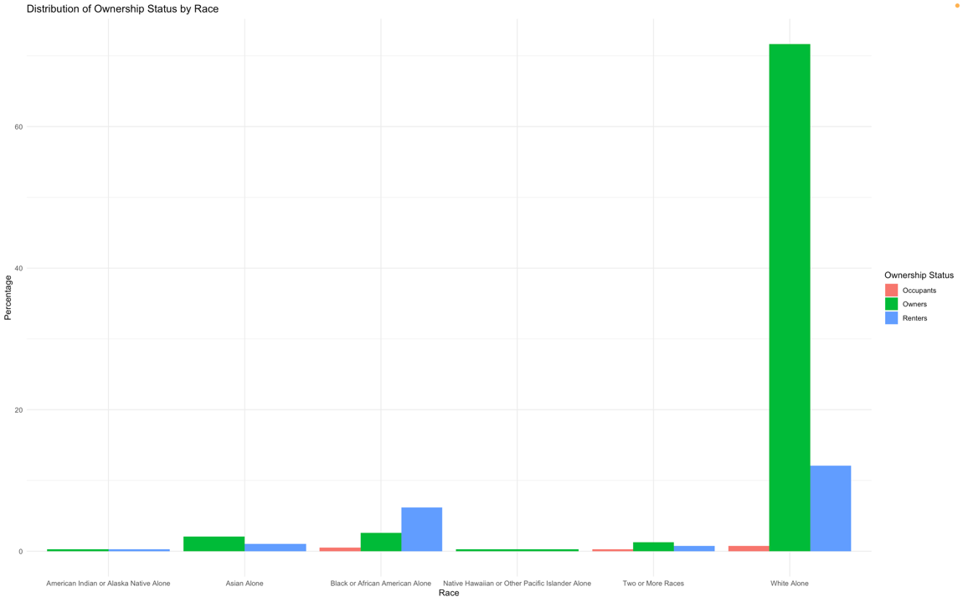

Figure 3: Distribution of Ownership Status by Race

This figure provides a detailed breakdown of homeownership by race, revealing disparities in housing ownership across different racial groups. White respondents significantly outnumber other races in homeownership, which aligns with historical trends of racial disparities in property ownership.

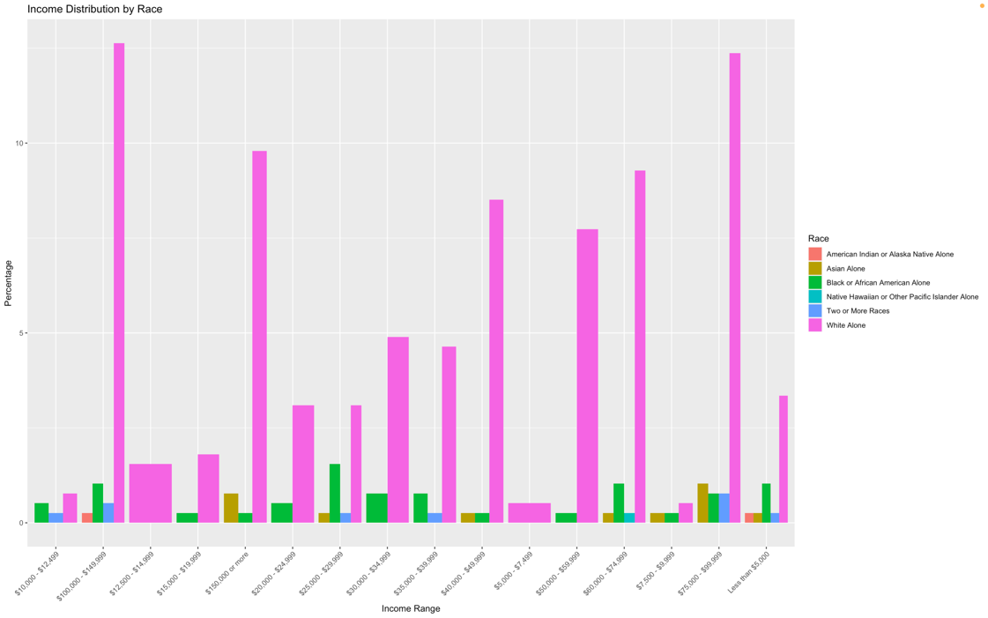

Figure 4: Income Distribution by Race

This figure shows the distribution of income ranges among different racial groups, indicating economic disparities where White households tend to have higher income brackets than other races.

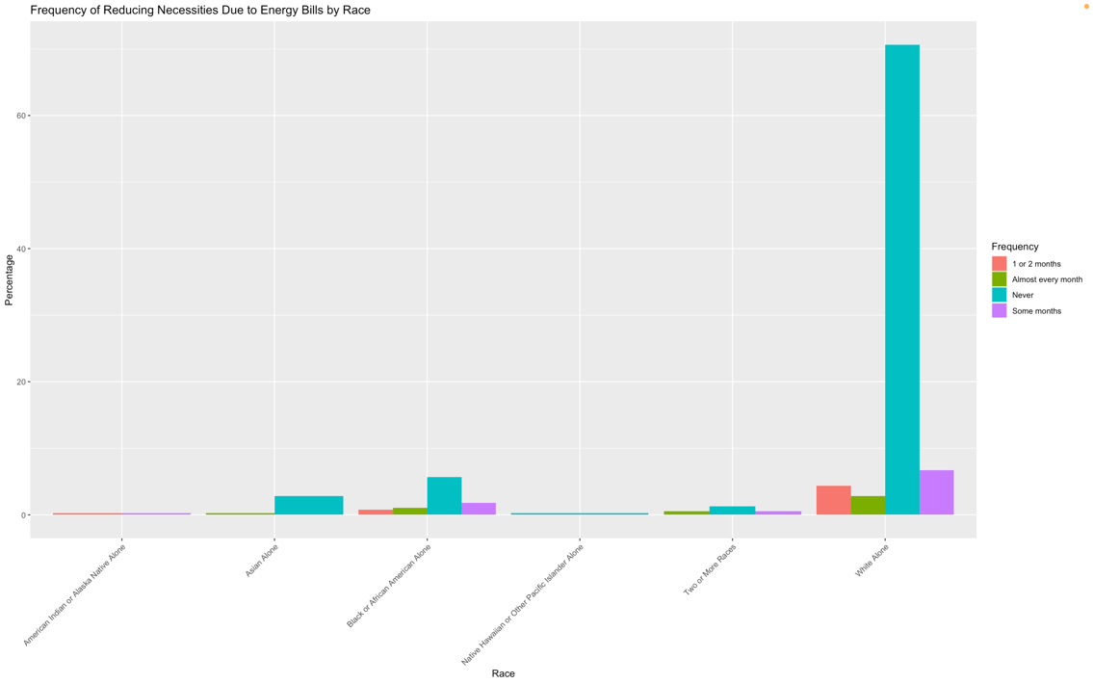

Figure 5: Frequency of Reducing Necessities Due to Energy Bills by Race

This figure examines the frequency at which different races face challenges in paying energy bills, highlighting higher instances of energy insecurity among Black or African American respondents.

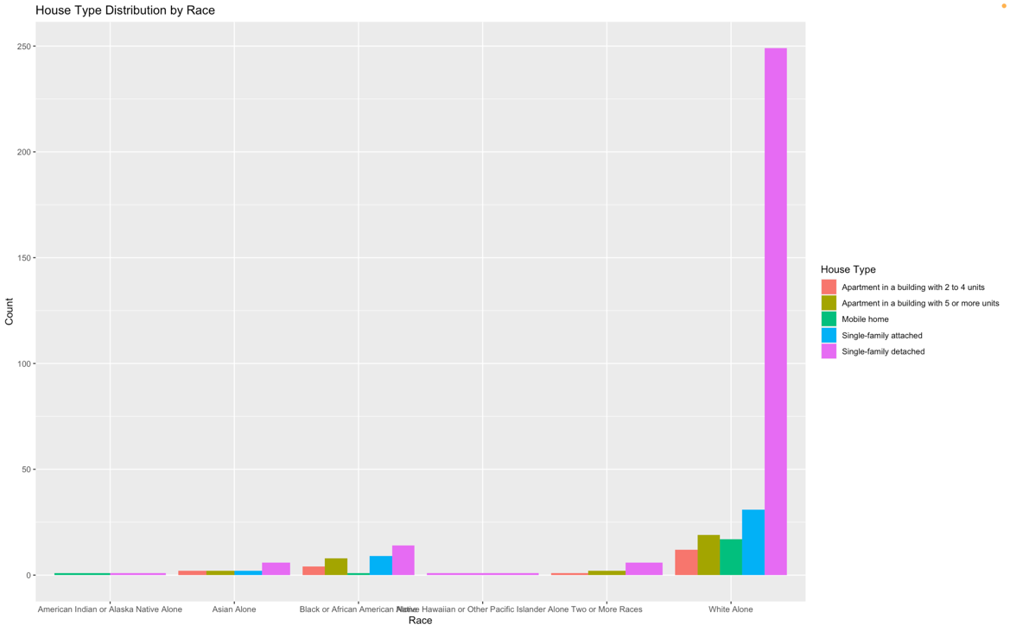

Figure 6: House Type Distribution by Race

This bar chart depicts the distribution of ownership status by race, highlighting significant disparities in homeownership among different racial groups.

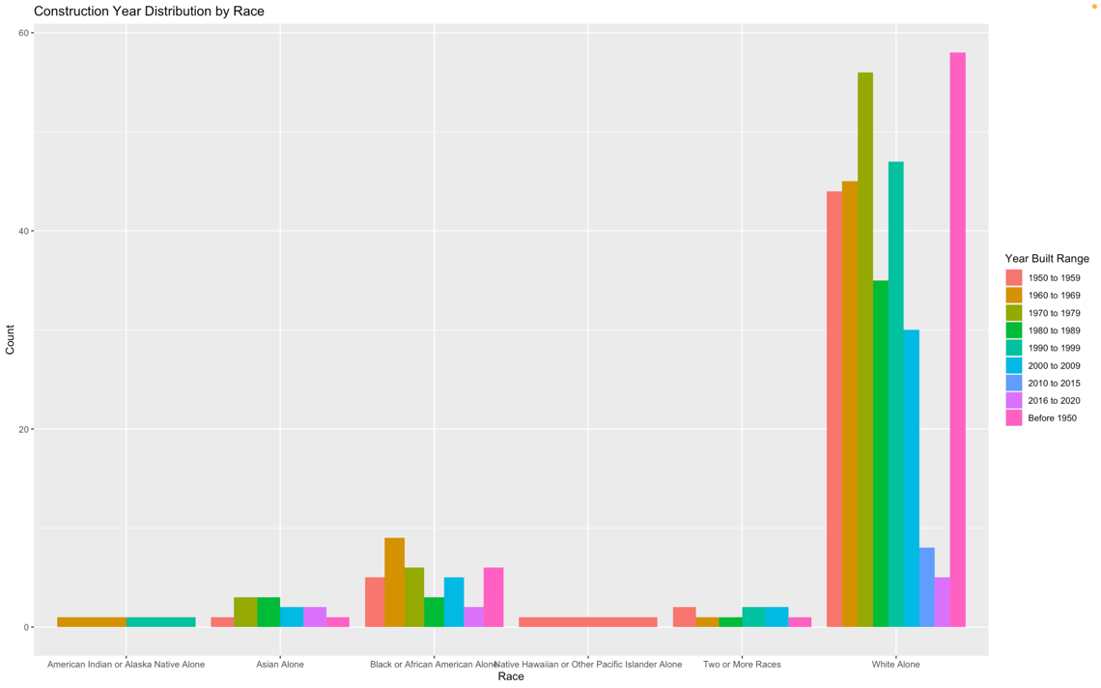

Figure 7: Construction Year Distribution by Race

The bar chart presents the distribution of housing by construction year across different racial groups. It highlights that most of the housing occupied by White respondents includes homes built across a wide range of years, with a significant portion from the most recent decades (1990 to 2020).

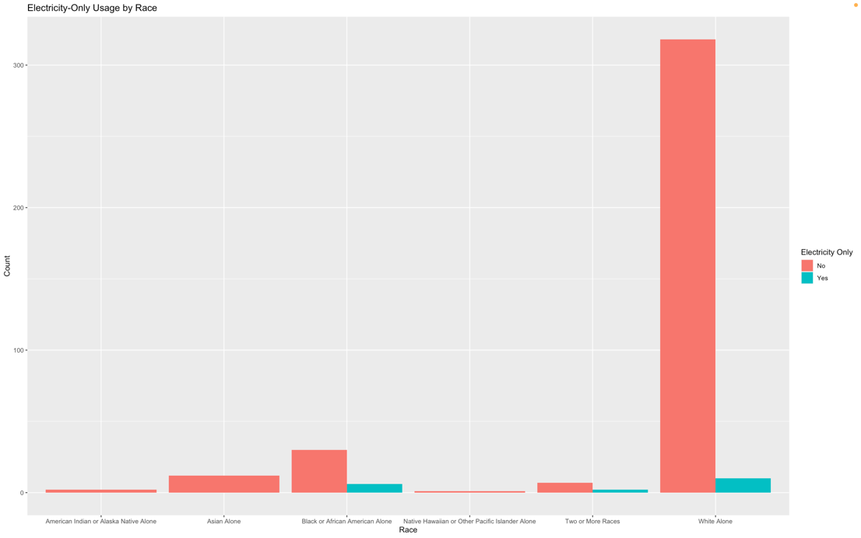

Figure 8: Electricity-Only Usage by Race

This chart illustrates the distribution of households relying solely on electricity for energy by race.

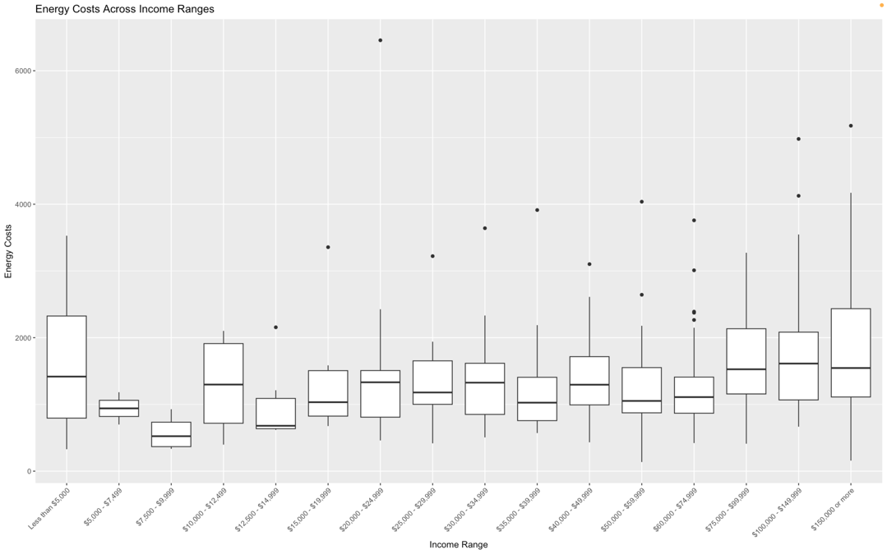

Figure 9: Energy Costs Across Income Ranges

The above analysis clearly illustrates significant disparities in homeownership and energy burden across racial lines, with historical redlining practices contributing to persistent economic and racial inequities in Michigan. White households exhibit a higher rate of homeownership and reside predominantly in newer, more energy-efficient homes, contrasting sharply with the conditions faced by Black and other minority groups.

# DISCUSSION

## CONTEXT AND FOCUS OF THE STUDY

This research study investigates the link between historical redlining and present energy burdens in Michigan, a state with a long history of racial segregation and economic inequity. Michigan was chosen expressly for its diversified demographics and stark contrasts between urban and suburban areas, providing a unique viewpoint on systemic concerns related to energy insecurity.

Historical redlining practices, institutionalized by the Home Owners' Loan Corporation (HOLC) during the 1930s, have long-lasting effects on urban landscapes and racial disparities. HOLC's maps graded neighborhoods from "A" (best) to "D" (hazardous), primarily based on racial composition, profoundly affecting the investment and quality of infrastructure in these areas. This grading system influenced residential stability and economic opportunities for decades, contributing to ongoing disparities in homeownership and access to energy-efficient housing.

## RACIAL AND ECONOMIC DISPARITIES IN ENERGY BURDEN

The Residential Energy Consumption Survey (RECS) 2020 findings highlight significant disparities in homeownership, income levels, energy costs, and housing types across different racial groups. These disparities confirm the existence of substantial energy burdens among minority populations, particularly among Black or African American communities. The box plot above visualizes the distribution of energy costs across various income ranges. This visualization highlights some key trends:

* Median Energy Costs: The median energy costs, indicated by the line within each box, tend to increase as income ranges increase. This increase suggests that higher-income households may consume more energy or have larger homes with higher energy costs.
* Spread and Variability: The range of energy costs within each income bracket varies, with higher income brackets showing wider spreads. This range could be due to a diversity in the types and sizes of housing and differences in energy usage patterns.
* Outliers: The presence of outliers, particularly in higher income ranges, suggests that households within these brackets have significantly higher energy costs than their peers. These outliers may represent substantial homes or less energy-efficient properties.
* Lower Income Ranges: The boxes are narrower in the lowest income ranges, which indicates less variability in energy costs. However, the costs still represent a significant part of their income, which can imply a higher energy burden relative to their income.

This box plot is essential for understanding how energy costs are distributed across different economic segments and can provide insights into the energy burden lower versus higher-income households face.

## HOMEOWNERSHIP AND HOUSING STABILITY

According to my data, White people own homes at a disproportionate rate, which offers them more financial and residential stability. Acquiring a home is essential for building wealth since it influences one's ability to access resources that lower energy expenses. The distribution of ownership status by race is shown in the bar chart, demonstrating the notable differences in homeownership between various racial groupings. The predominant green bar indicates that homeowners make up the vast majority of White respondents. Meanwhile, among other racial groups, like Asian, Black, or African American, and those who identify as multiracial, homeownership is comparatively underrepresented. There are also small proportions of renters (blue bars) and occupants not paying rent (red bars) across these racial categories, with the White category again showing a substantial number of renters compared to other races. This visualization effectively illustrates racial disparities in housing ownership and rental status in the examined demographic.

## INCOME DISPARITIES

Income distribution data shows economic disparities, with White households more likely to be in higher income brackets. This financial advantage contributes to a lower energy burden compared to other racial groups who earn less and thus spend a higher proportion of their income on energy.

## ENERGY INSECURITY AND RACIAL DISPARITIES

The study highlights more frequent energy insecurity among Black or African American respondents, manifested in higher rates of difficulties managing energy expenses. These findings align with previous research indicating that energy insecurity is a compounded issue of economic hardship intertwined with racial inequities.

Interpretation of Chi-squared Test for NOHEATBROKE

* Statistic (X-squared): 3.445632
* Degrees of freedom (df): 5
* P-value: 0.6316

This test assesses whether there's a statistically significant association between HOUSEHOLDER_RACE and the inability to use heating equipment because it was broken (NOHEATBROKE) across different races. The Chi-squared statistic is 3.445632 with 5 degrees of freedom. The relatively high p-value of 0.6316 suggests no statistically significant association between race and the likelihood of my dataset's heating equipment being unusable due to breakage**. Based on my dataset, different racial groups do not exhibit significant variation in their inability to use heating equipment due to it being broken.**

Interpretation of Chi-squared Test for SCALEE (Disconnection Notices)

* Statistic (X-squared): 40.89633
* Degrees of freedom (df): 15
* P-value: 0.000331638

This test examines the association between HOUSEHOLDER_RACE and the frequency of receiving disconnection notices (SCALEE). The Chi-squared statistic here is 40.89633 with 15 degrees of freedom. The p-value is extremely low (0.000331638), indicating a statistically significant association between the race of the household and the frequency of receiving disconnection notices. This result suggests that different racial groups experience significantly different rates of disconnection notices, pointing to potential racial disparities in energy security.

## HOUSING TYPE AND CONSTRUCTION YEAR

It is evident by looking into housing type and construction year that minority groups tend to have older, less energy-efficient homes. The energy load on the occupants of these dwellings is exacerbated by the fact that they often have higher energy costs. The distribution of houses across various racial groups by year of construction is shown in the bar chart. It emphasizes that although White respondents occupy a majority of homes built throughout a wide range of years, a sizable fraction date from the most recent decades (1990 to 2020). In contrast, there is typically a lower number and less variation in the years of construction for buildings occupied by other racial groups, such as Asian, American Indian or Alaska Native, Black or African American, and with fewer dwellings from the most recent decades. This data may suggest disparities in the age and possibly the quality of housing accessible to different racial groups, reflecting broader socio-economic patterns.

## RACIAL DISPARITIES IN ENERGY SOURCE RELIANCE AND ITS ECONOMIC IMPLICATIONS

From my analysis, most White households exclusively use electricity, dwarfing the counts observed in other racial categories. This skew toward electricity usage among White households suggests they may benefit from the lower costs and stability associated with electric heating and cooling systems. Conversely, minority groups, who are less likely to rely solely on electricity, may face higher energy costs and less stable supply, particularly if they depend on natural gas, which can be more expensive and less consistently available. This disparity highlights an additional dimension of energy inequality, where access to more affordable and reliable energy sources is not uniformly distributed across racial lines.

This discussion integrates the legacy of HOLC's redlining practices and their continuing impact on current energy access and economic stability disparities, highlighting the critical need for policies addressing these ingrained inequalities.

# LIMITATIONS OF THE STUDY

This study faced several limitations that may affect the generalizability of the findings:

* Missing Data: There were considerable amounts of missing data, particularly concerning respondents who underwent energy assistance programs and those facing various energy insecurities. This limitation restricts the depth of analysis possible in these areas.

* Demographic Imbalance: The dataset predominantly consisted of White individuals, which could skew the results and might not accurately reflect the conditions of more diverse populations.
* No cities in the dataset: The data obtained from RECS did not include city information, so I was unable to determine which cities in Michigan are facing energy burdens.

# RECOMMENDATIONS FOR FURTHER RESEARCH

In my opinion, due to the significant limitations noted, particularly the lack of complete datasets on energy assistance and insecurities, further research is recommended. This research should focus on obtaining more comprehensive data across different states and cities with varied demographic compositions to understand better the broad implications of energy burdens and the lasting effects of historical redlining.

# CONCLUSION

This research has systematically explored the intersection of race, housing, and energy burdens within Michigan, a state with a historically significant backdrop of segregation influenced by policies such as those implemented by the Home Owners' Loan Corporation (HOLC). By utilizing the latest Residential Energy Consumption Survey (RECS) data, this study has provided a detailed examination of how historical injustices continue to shape diverse communities' economic realities and energy consumption patterns.

According to my research, there are significant racial differences in homeownership rates and energy cost burdens. The majority of white households are homeowners, and they are more likely to get all of their energy from electricity. Because they are more likely to rely on less efficient and more expensive energy sources, such as natural gas, ethnic minorities are likely to face higher energy expenses as a result of this predominance. Furthermore, the statistics highlighted a crucial aspect of energy inequality by showing that Black or African American households are disproportionately affected by energy vulnerabilities, such as the frequency of disconnection warnings and the inability to heat homes.

Significant drawbacks to this study were a high rate of missing data and a demographic distribution that was strongly skewed towards White people, which may have distorted views of circumstances in the state. Furthermore, the amount of analysis that could be done in these important areas was limited by the absence of thorough data on participation in energy assistance programs and particular indicators of energy insecurity.

In light of these findings and limitations, this research underscores the urgent need for more comprehensive data collection and further studies that include a broader range of demographic groups and geographic areas. Such efforts would provide a more detailed understanding of the ongoing impacts of historical segregation on current energy burdens and inform policy interventions to rectify these deep-seated disparities. Future research should aim to include more granular data, allowing for a nuanced analysis of the mechanisms driving racial disparities in energy access and economic stability within the energy sector.

# REFERENCES

1. Winling, L. C., & Michney, T. M. (2021). The roots of redlining: Academic, governmental, and professional networks in the making of the new deal lending regime. *Journal of American History*, *108*(1), 42–69. <https://doi.org/10.1093/jahist/jaab066>
2. Fisher, Sheehan & Colton. 2020. "Home Energy Affordability Gap." Fisher, Sheehan & Colton. http://www.homeenergyaffordabilitygap.com/index.html.
3. Traub, Amy, Catherine Ruetschlin, Laura Sullivan, Tatjana Meschede, Lars Dietrich, and Thomas Shapiro. 2016. "The Racial Wealth Gap: Why Policy Matters." Demos.

<https://www.demos.org/research/racial-wealth-gap-why-policy-matters>.

1. Richardson, Jason, Bruce C. Mitchell, Helen C. S. Meier, Emily Lynch, Jad Edlebi, Robert K.
2. Nelson, and Justin M. Madron. n.d. "Redlining and Neighborhood Health." National Community Reinvestment Coalition. https://ncrc.org/holc-health/.
3. Lane, Haley M., Rachel Morello-Frosch, Julian D. Marshall, and Joshua S. Apte. 2022. "Historical Redlining Is Associated with Present-Day Air Pollution Disparities in U.S. Cities." *American Chemical Society*, March. https://doi.org/10.1021/acs.estlett.1c01012
4. U.S. Environmental Protection Agency. 2022. "Environmental Justice." EPA. https://www.epa.gov/environmentaljustice/learn-about-environmental-justice. ———. n.d. "Heat Island Effect." https://www.epa.gov/heatislands.
5. Kontokosta, Constantine E., Vincent J. Reina, and Bartosz BonCzak. 2020. "Energy Cost Burdens for Low-Income and Minority Households." *Journal of the American Planning Association* 86 (1): 89–105. https://doi.org/10.1080/01944363.2019.1647446.
6. Drehobl, A., Ross, L., & Ayala, R. (2020). How high are household energy burdens. *An Assessment of National and Metropolitan Energy Burdens across the U.S*.
7. Pittman, L. (2023). Energy Justice Addressing Energy Burden Inequalities and the Electricity Grid's Infrastructure Inequities. *Natural Resources & Environment*, *37*(3), 21-25.
8. Aaronson, D., Faber, J., Hartley, D., Mazumder, B., & Sharkey, P. (2020). *The long-run effects of the 1930s HOLC "redlining" maps on place-based measures of economic opportunity and socio-economic success*. Federal Reserve Bank of Chicago. <http://dx.doi.org/10.21033/wp-2020-33>
9. Appel, I. (2016). Pockets of poverty: The long-term effects of redlining. *SSRN Electronic Journal*. <https://doi.org/10.2139/ssrn.2852856>
10. Air, F. (2015, May 14). Historian says don't "sanitize" how our government created ghettos. *Fresh Air*. https://www.npr.org/2015/05/14/406699264/historian-says-dont-sanitize-how-our-government-created-the-ghettos
11. An, B., Orlando, A. W., & Rodnyansky, S. (2019). The Physical Legacy of Racism: How redlining cemented the modern built environment. *SSRN Electronic Journal*. https://doi.org/10.2139/ssrn.3500612
12. Bertocchi, G., & Dimico, A. (2020). *COVID-19, race, and redlining*. Cold Spring Harbor Laboratory. http://dx.doi.org/10.1101/2020.07.11.20148486
13. Chicago: University of Chicago Press. (1922). The Chicago Commission on Race Relations, The Negro in Chicago. A study of race relations and a race riot. *The Journal of Negro History*, *8*(1), 112–114. https://doi.org/10.2307/2713467
14. Clarke, A., Deru, M., Lockhart, E., Beshilas, L., Paranjothi, G., Wiltse, N., Belding, S., Jackson, R., Radhakrishnan, N., Egea-Casalduc, M., Grimes, K., & Engelman, B. (2023). *Centering energy and environmental justice in the buildings energy sector*. Office of Scientific and Technical Information (OSTI). http://dx.doi.org/10.2172/2005548
15. Cooney, T., & Jackson, K. T. (1987). Crabgrass frontier: The suburbanization of the United States. *The History Teacher*, *20*(3), 441. https://doi.org/10.2307/493138
16. Data_cdc_places. (2018, September 25). *500 Cities Project All Measures 2016*. https://cdcarcgis.maps.arcgis.com/home/item.html?id=04bd589e13c242d98de43e78f90d0d3f#overview
17. Gross, T. (2017, May 3). A "forgotten history" of how the U.S. government segregated America. *Fresh Air*. https://www.npr.org/2017/05/03/526655831/a-forgotten-history-of-how-the-u-s-government-segregated-america
18. Hillier, A. E. (2003). Redlining and the homeowners' loan corporation. *Journal of Urban History*, *29*(4), 394–420. https://doi.org/10.1177/0096144203029004002
19. Jackson, K. T. (1980). Race, ethnicity, and real estate appraisal. *Journal of Urban History*, *6*(4), 419–452. https://doi.org/10.1177/009614428000600404
20. Li, D., Newman, G. D., Wilson, B., Zhang, Y., & Brown, R. D. (2021). Modeling the relationships between historical redlining, urban heat, and heat-related emergency department visits: An examination of 11 Texas cities. *Environment and Planning B: Urban Analytics and City Science*, *49*(3), 933–952. https://doi.org/10.1177/23998083211039854
21. Massey, D. S., & Denton, N. A. (2018). American apartheid: Segregation and the making of the underclass. In *inequality in the 21st century* (pp. 143–150). Routledge. http://dx.doi.org/10.4324/9780429499821-27
22. Nardone, A., Chiang, J., & Corburn, J. (2020). Historic redlining and urban health today in U.S. cities. *Environmental Justice*, *13*(4), 109–119. https://doi.org/10.1089/env.2020.0011
23. NPR. (2017, March 31). Everyone pays A hefty price for segregation, study says. *NPR*. https://www.npr.org/sections/codeswitch/2017/03/31/522098019/everyone-pays-a-hefty-price-for-segregation-study-says
24. Rothstein, R. (2017). *The color of law: A forgotten history of how our government segregated america*. Liveright Publishing.
25. Swope, C. B., Hernández, D., & Cushing, L. J. (2022). The relationship of historical redlining with present-day neighborhood environmental and health outcomes: A scoping review and conceptual model. *Journal of Urban Health*, *99*(6), 959–983. https://doi.org/10.1007/s11524-022-00665-z
26. Tsai, W.-L., Nash, M. S., Rosenbaum, D. J., Prince, S. E., D’Aloisio, A. A., Mehaffey, M. H., Sandler, D. P., Buckley, T. J., & Neale, A. C. (2023). Association of redlining and natural environment with depressive symptoms in women in the sister study. *Environmental Health Perspectives*, *131*(10). https://doi.org/10.1289/ehp12212
27. Winling, L. C., & Michney, T. M. (2021). The roots of redlining: Academic, governmental, and professional networks in the making of the new deal lending regime. *Journal of American History*, *108*(1), 42–69. <https://doi.org/10.1093/jahist/jaab066>
28. Yancy, C. W. (2020). COVID-19 and African americans. *JAMA*, *323*(19), 1891. <https://doi.org/10.1001/jama.2020.6548>
29. Swope, C. B., Hernández, D., & Cushing, L. J. (2022b). The relationship of historical redlining with present-day neighborhood environmental and health outcomes: A scoping review and conceptual model. *Journal of Urban Health*, *99*(6), 959–983. <https://doi.org/10.1007/s11524-022-00665-z>
30. Weisbrod, K. (2022, May 20). *New York is facing a pandemic-fueled home energy crisis, with no end in sight*. Inside Climate News. https://insideclimatenews.org/news/20052022/new-york-utility-bills/
31. Wilson, B. (2020). Urban heat management and the legacy of redlining. *Journal of the American Planning Association*, *86*(4), 443–457. <https://doi.org/10.1080/01944363.2020.1759127>